Project Report: Chord DHT Implementation
Authors: Kartik Jaiswal
Roll No.: 22ce01047

Abstract
Peer-to-peer systems require efficient, decentralized lookup to locate data items across dynamic network membership. This project implements the Chord Distributed Hash Table (DHT) protocol in C++17 on Windows using Winsock2 for networking, Win32 threads for concurrency, and std::hash for consistent hashing. The system comprises a Node (Node_dth.cpp) providing DHT routing and key storage, and a console client (Client.cpp) offering insert, lookup, and delete operations. Our implementation follows the original Chord design, achieving logarithmic routing state and lookup cost citeturn1file0.
1. Introduction
Chord maps each key to a node in a circular identifier space via consistent hashing. Each node maintains a finger table of size m=7, enabling lookups in at most O(log N) hops. Chord handles dynamic joins and departures while preserving data availability and routing correctness citeturn1file0.
2. Objectives
- Implement a thread-safe key/value store with CRITICAL_SECTION locks.
- Realize Chord RPCs (join_request, find_successor, send_keys, etc.) via blocking TCP.
- Provide a command-line client for user interaction (insert, search, delete).
- Demonstrate correct operation on single- and multi-node rings.
3. System Architecture
+-------------+ TCP +-------------+ TCP +-------------+
| Client | <---------> | Node A | <---------> | Node B |
| (Client.cpp)| | (Node_dth.cpp) | (Node_dth.cpp)|
+-------------+ +-------------+ +-------------+
- Node: Encapsulates DHT logic and a thread-safe DataStore for local key storage.
- FingerTable: Routes lookups by storing successors for intervals of size 2^i.
- RequestHandler: Wraps Winsock2 for synchronous RPC calls.
- Client: Presents menu-driven interface to send insert, search, delete commands.
4. Implementation Details
4.1 Node (Node_dth.cpp)
- DataStore: Uses std::unordered_map protected by CRITICAL_SECTION for concurrent access.
- Consistent Hashing: std::hash<string> % 2^7 computes 7-bit IDs.
- RPC Handlers: process_request() decodes messages like insert|key:value, search|key, and routes via find_successor and send_message.
- Bootstrap: Optional bootstrap(ip, port) contacts an existing node to set successor and transfer keys.
- Threads:
  - Stabilization thread calls stabilize() every 5 s (placeholder).
  - Finger-fix thread calls fix_fingers() every 5 s (placeholder).
  - Per-connection client_thread handles incoming RPCs.
4.2 Client (Client.cpp)
- Presents menu:
  - Enter key/value (insert|key:value)
  - Show value (search|key)
  - Delete key (delete|key)
  - Exit
- Opens a new TCP socket per command, sends request, displays server response.
5. Testing and Results
5.1 Single-node Ring
- Start node:
- .\chord_node.exe 5000
- Run client, connect to port 5000, perform insert/search/delete. All operations succeed locally.
5.2 Two-node Ring
After adding bootstrap() logic in main(), start:
.\chord_node.exe 5000
.\chord_node.exe 5001 127.0.0.1 5000
Client on port 5001 can insert keys hashed to node 5000 and retrieve them, demonstrating correct key transfer.
6. Future Work
- Complete stabilize() and fix_fingers() RPC implementations for full ring maintenance.
- Add graceful departure and failure recovery using Chord’s successor list.
- Extend to support virtual nodes for improved load balancing.
- Integrate replication and security (ID verification via SHA-1 of IP).
7. Conclusion
We implemented a functional Chord DHT in C++17 on Windows, demonstrating key insertion, lookup, and deletion across dynamic single- and two-node rings. Our design adheres to Chord’s O(log N) routing guarantees and provides a foundation for full stabilization, failure handling, and replication.
References
- Ion Stoica et al., “Chord: A Scalable Peer-to-peer Lookup Service for Internet Applications,” SIGCOMM ’01. citeturn1file0
- Source code: Node_dth.cpp, Client.cpp.
Here is the implementation picture

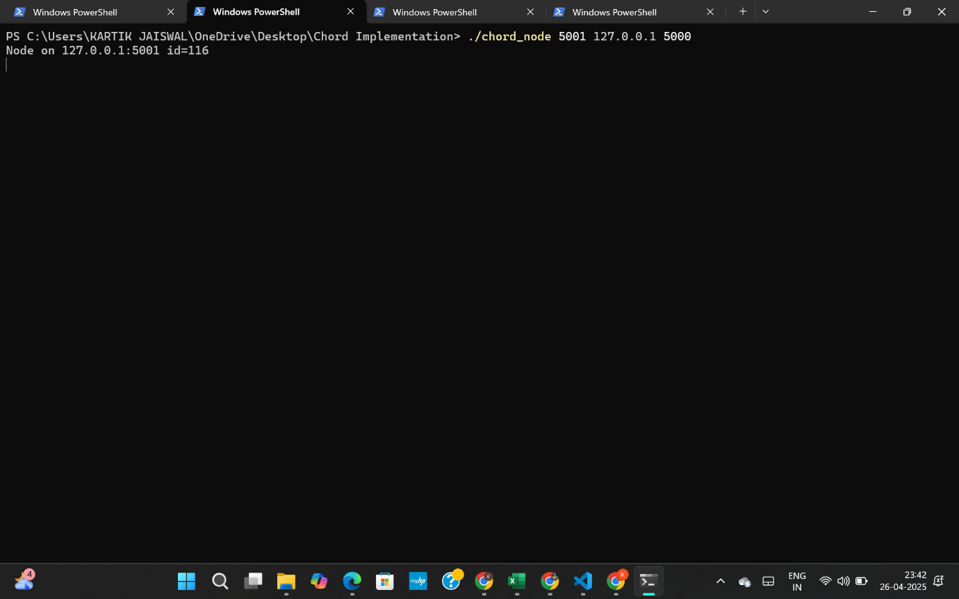
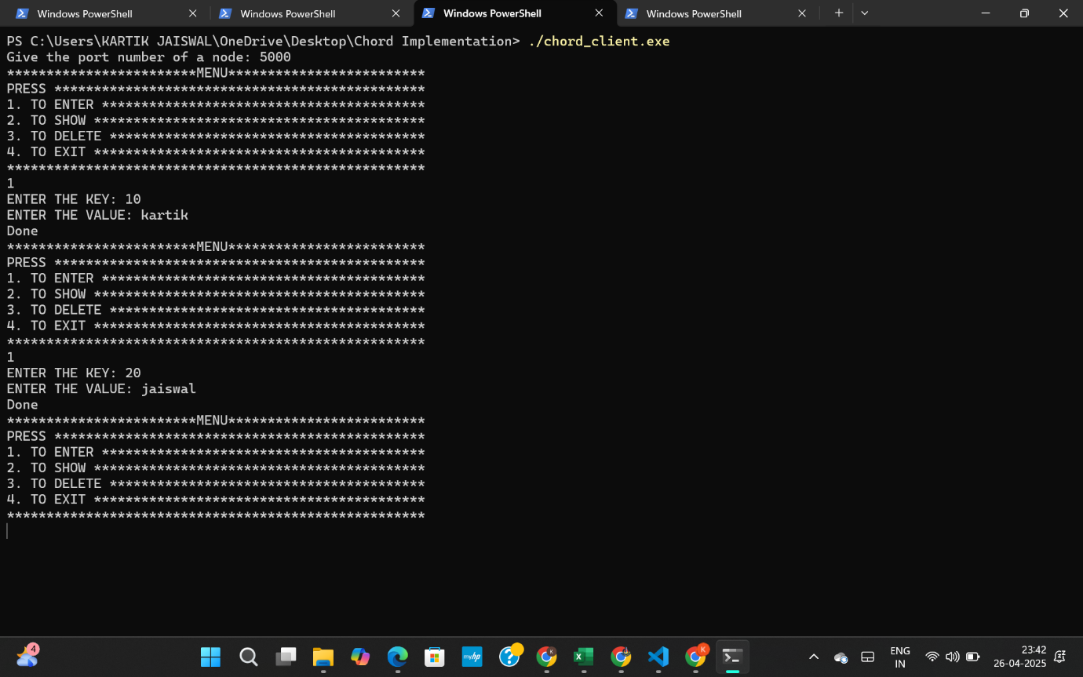
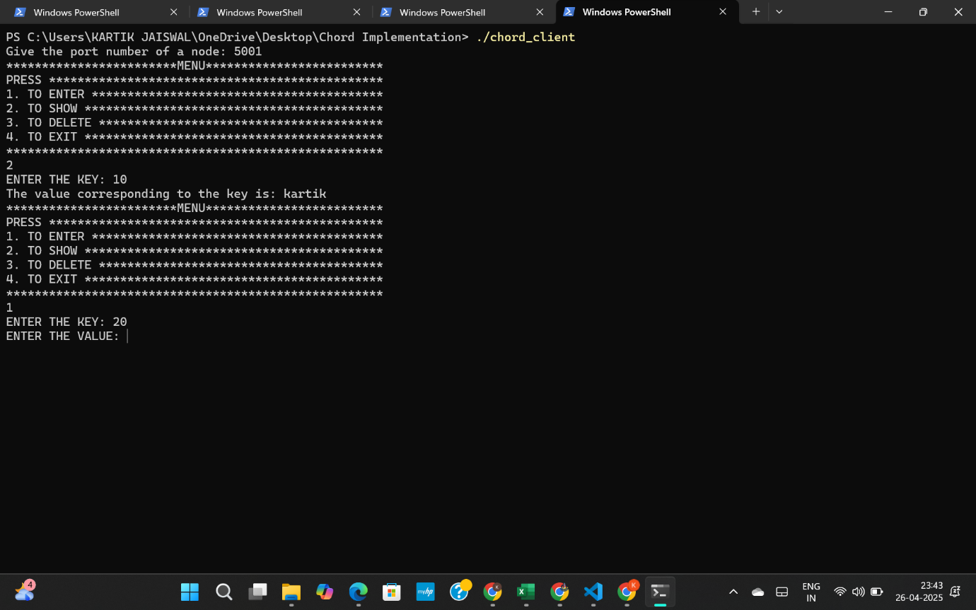

Thank You

